**PharmLabs San Diego** Certificate of Analysis

3421 Hancock St, Second Floor, San Diego, CA 92110 | License: C8-0000098-LIC ISO/IEC 17025:2017 Accredited L17-427-1 #[85368](https://www.dropbox.com/s/l983yoy8rtdtn0q/L21-599%20PharmLabs%20San%20Diego.pdf?dl=0)

Sample **Kratom Extract/Powder**

Sample ID **SD230817-041 (82817)** Matrix **Concentrate (Inhalable Cannabis Good)** Batch ID **230712**

Tested for **Baklava Sticks llc**

Sampled **-** Received **Aug 16, 2023** Reported **Aug 25, 2023**

Analyses executed **RES, MIBNIG, MTO, PES, HME, KTM**

# HME - Heavy Metals Analysis

Analyzed **Aug 22, 2023** | Instrument **ICP/MSMS** | Method **SOP-005**

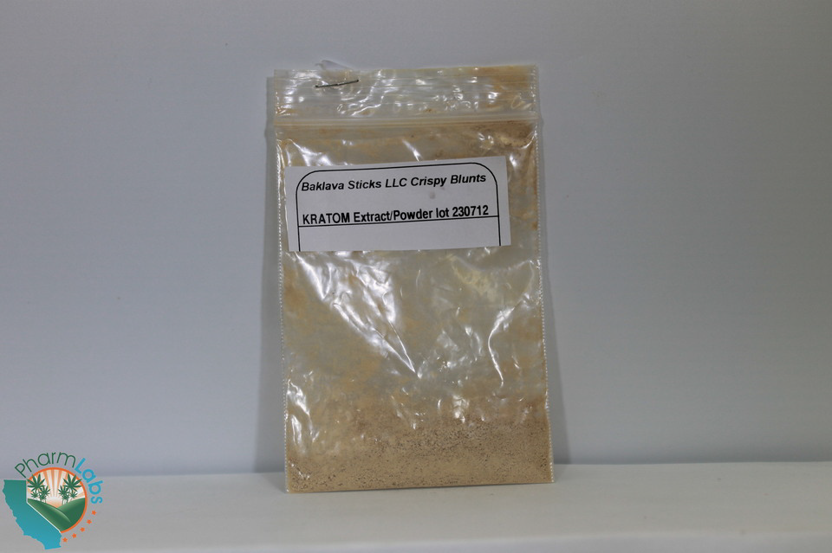

Arsenic (As)

0.0009

0.0027

**0.00**

1.5

Mercury (Hg)

0.0058

0.0174

**ND**

3

0.5

**0.07**

0.0018

0.0006

Lead (Pb)

0.5

**ND**

0.0015

0.0005

Cadmium (Cd)

**Sample photography**

**Limit ug/g**

**Result ug/g**

**LOQ**

**ug/g**

**LOD**

**ug/g**

**Analyte**

Nickel (Ni) 6.0e-05 0.0002 **ND**

# MIBNIG - Microbial Analysis

Analyzed **Aug 21, 2023** | Instrument **Plating** | Method **SOP-007**

**Analyte**

**Result CFU/g**

**Limit**

**Analyte**

**Result CFU/g**

**Limit**

Shiga toxin-producing Escherichia Coli **ND** ND per 1 gram Salmonella spp. **ND** ND per 1 gram

# MTO - Mycotoxin Analysis

Analyzed **Aug 24, 2023** | Instrument **LC/MSMS** | Method **SOP-004**

**Analyte**

**LOD LOQ**

**ug/kg ug/kg**

**Result ug/kg (ppb)**

**Limit ug/kg**

**Analyte**

**LOD LOQ**

**ug/kg ug/kg**

**Result ug/kg (ppb)**

**Limit ug/kg**

Ochratoxin A 5.0 20.0 **ND** 20 Aflatoxin B1 2.5 5.0 **ND** -

Aflatoxin B2 2.5 5.0 **ND** - Aflatoxin G1 2.5 5.0 **ND** -

Aflatoxin G2 2.5 5.0 **ND** - Total Aflatoxins 10.0 20.0 **ND** 20

# PES - Pesticides Analysis

Analyzed **Aug 24, 2023** | Instrument **LC/MSMS GC/MSMS** | Method **SOP-003**



**Analyte**

**LOD**

**ug/g**

**LOQ**

**ug/g**

**Result ug/g**

**Limit ug/g**

**Analyte**

**LOD**

**ug/g**

**LOQ**

**ug/g**

**Result ug/g**

**Limit ug/g**

Aldicarb 0.0078 0.02 **ND** 0.0078 Carbofuran 0.01 0.02 **ND** 0.01



Dimethoate 0.01 0.02 **ND** 0.01 Etofenprox 0.02 0.1 **ND** 0.02

Fenoxycarb 0.01 0.02 **ND** 0.01 Thiachloprid 0.01 0.02 **ND** 0.01



Daminozide 0.01 0.03 **ND** 0.01 Dichlorvos 0.02 0.07 **ND** 0.02

Imazalil 0.02 0.07 **ND** 0.02 Methiocarb 0.01 0.02 **ND** 0.01



Spiroxamine 0.01 0.02 **ND** 0.01 Coumaphos 0.01 0.02 **ND** 0.01

Fipronil 0.01 0.1 **ND** 0.01 Paclobutrazol 0.01 0.03 **ND** 0.01



Chlorpyrifos 0.01 0.04 **ND** 0.01 Ethoprophos (Prophos) 0.01 0.02 **ND** 0.01

Baygon (Propoxur) 0.01 0.02 **ND** 0.01 Chlordane 0.04 0.1 **ND** 0.04



Chlorfenapyr 0.03 0.1 **ND** 0.03 Methyl Parathion 0.02 0.1 **ND** 0.02

Mevinphos 0.03 0.08 **ND** 0.03 Abamectin 0.03 0.08 **ND** 0.1



Acephate 0.02 0.05 **ND** 0.1 Acetamiprid 0.01 0.05 **ND** 0.1

Azoxystrobin 0.01 0.02 **ND** 0.1 Bifenazate 0.01 0.05 **ND** 0.1



Bifenthrin 0.02 0.35 **ND** 3 Boscalid 0.01 0.03 **ND** 0.1

Carbaryl 0.01 0.02 **ND** 0.5 Chlorantraniliprole 0.01 0.04 **ND** 10



Clofentezine 0.01 0.03 **ND** 0.1 Diazinon 0.01 0.02 **ND** 0.1

Dimethomorph 0.02 0.06 **ND** 2 Etoxazole 0.01 0.05 **ND** 0.1



Fenpyroximate 0.02 0.1 **ND** 0.1 Flonicamid 0.01 0.02 **ND** 0.1

Fludioxonil 0.01 0.05 **ND** 0.1 Hexythiazox 0.01 0.03 **ND** 0.1



Imidacloprid 0.01 0.05 **ND** 5 Kresoxim-methyl 0.01 0.03 **ND** 0.1

Malathion 0.01 0.05 **ND** 0.5 Metalaxyl 0.01 0.02 **ND** 2



Methomyl 0.02 0.05 **ND** 1 Myclobutanil 0.02 0.07 **ND** 0.1

Naled 0.01 0.02 **ND** 0.1 Oxamyl 0.01 0.02 **ND** 0.5



Permethrin 0.01 0.02 **ND** 0.5 Phosmet 0.01 0.02 **ND** 0.1

Piperonyl Butoxide 0.02 0.06 **ND** 3 Propiconazole 0.03 0.08 **ND** 0.1



Prallethrin 0.02 0.05 **ND** 0.1 Pyrethrin 0.05 0.41 **ND** 0.5

Pyridaben 0.02 0.07 **ND** 0.1 Spinosad A 0.01 0.05 **ND** 0.1



Spinosad D 0.01 0.05 **ND** 0.1 Spiromesifen 0.02 0.06 **ND** 0.1

Spirotetramat 0.01 0.02 **ND** 0.1 Tebuconazole 0.01 0.02 **ND** 0.1



Thiamethoxam 0.01 0.02 **ND** 5 Trifloxystrobin 0.01 0.02 **ND** 0.1

Acequinocyl 0.02 0.09 **ND** 0.1 Captan 0.01 0.02 **ND** 0.7



Cypermethrin 0.02 0.1 **ND** 1 Cyfluthrin 0.04 0.1 **ND** 2

Fenhexamid 0.02 0.07 **ND** 0.1 Spinetoram J,L 0.02 0.07 **ND** 0.1



Pentachloronitrobenzene 0.01 0.1 **ND** 0.1

# RES - Residual Solvents Analysis

Analyzed **Aug 24, 2023** | Instrument **GC/FID with Headspace Analyzer** | Method **SOP-006**



**Analyte**

**LOD**

**ug/g**

**LOQ**

**ug/g**

**Result ug/g**

**Limit ug/g**

**Analyte**

**LOD**

**ug/g**

**LOQ**

**ug/g**

**Result ug/g**

**Limit ug/g**

Propane (Prop) 0.4 40.0 **ND** Butane (But) 0.4 40.0 **ND**



Methanol (Metha) 0.4 40.0 **4675.9** Ethylene Oxide (EthOx) 0.4 0.8 **ND**

Pentane (Pen) 0.4 40.0 **ND** Ethanol (Ethan) 0.4 40.0 **ND**



Ethyl Ether (EthEt) 0.4 40.0 **ND** Acetone (Acet) 0.4 40.0 **ND**

Isopropanol (2-Pro) 0.4 40.0 **ND** Acetonitrile (Acetonit) 0.4 40.0 **ND**



Methylene Chloride (MetCh) 0.4 0.8 **ND** Hexane (Hex) 0.4 40.0 **ND**

Ethyl Acetate (EthAc) 0.4 40.0 **ND** Chloroform (Clo) 0.4 0.8 **ND**



Benzene (Ben) 0.4 0.8 **ND** 1-2-Dichloroethane (12-Dich) 0.4 0.8 **ND**

Heptane (Hep) 0.4 40.0 **ND** Trichloroethylene (TriClEth) 0.4 0.8 **ND**



Toluene (Toluene) 0.4 40.0 **ND** Xylenes (Xyl) 0.4 40.0 **ND**

# KTM - Kratom Analysis

Analyzed **Aug 24, 2023** | Instrument **HPLC VWD** | Method **SOP-KTM**

The expanded Uncertainty of the analysis is approximately ±**7.81**% at the 95% Confidence Level



**Analyte**

**LOD**

**ppm**

**LOQ**

**ppm**

**Result**

**%**

**Result mg/g**

7-hydroxy Mitragynine (7HMG) 0.008 0.025 **ND ND**



Mitragynine (MITG) 0.018 0.054 **91.42** **914.23**

Speciogynine (SPEG) 0.002 0.005 **ND ND**



Speciociliante (SPCL) 0.007 0.02 **ND ND**