SD230819-011 page 1 of 1 QA Testing

**PharmLabs San Diego** Certificate of Analysis

3421 Hancock St, Second Floor, San Diego, CA 92110 | License: C8-0000098-LIC ISO/IEC 17025:2017 Accredited L17-427-1 #[85368](https://www.dropbox.com/s/l983yoy8rtdtn0q/L21-599%20PharmLabs%20San%20Diego.pdf?dl=0)

Sample **Goomz Gummies**



Sample ID **SD230819-011 (82974)** Matrix **Edible (Other Cannabis Good)**



Tested for **SpikeMyc Inc.**



Sampled **-** Received **Aug 18, 2023** Reported **Aug 24, 2023**



Analyses executed **4AD, TRY, PSY** Unit Mass (g) **24.741** Num. of Servings **6** Serving Size (g) **4.12**

# 4AD - 4A-Dimethyltryptamine Analysis

Analyzed **Aug 24, 2023** | Instrument **NA**

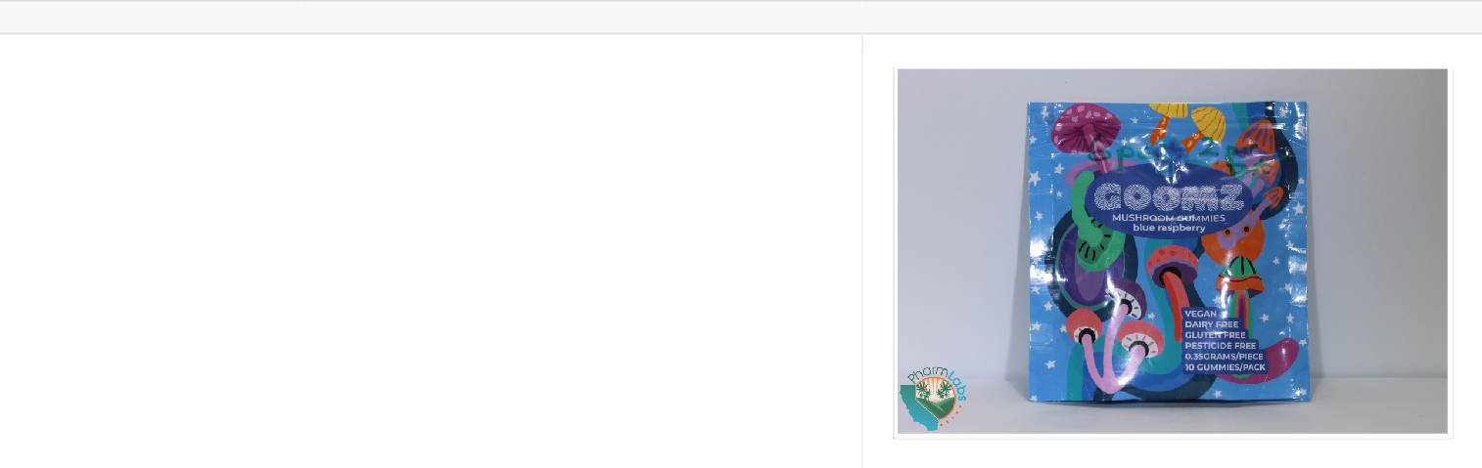

Psilacetin (PSLA)

0.29

0.88

**0.04**

**0.42**

**1.73**

**10.42**

**Sample photography**

**Result mg/Unit**

**Result mg/Serving**

**Result mg/g**

**Result**

**%**

**LOQ**

**ppm**

**LOD**

**ppm**

**Analyte**

# TRY - Tryptamine Analysis

Analyzed **Aug 24, 2023** | Instrument **NA**



**Analyte**

**LOD**

**ppm**

**LOQ**

**ppm**

**Result**

**%**

**Result mg/g**

**Result mg/Serving**

**Result mg/Unit**

Norbaeocystin (NORB) 0.192 0.581 **ND ND ND ND**



Baeocystin (BAEO) 0.192 0.581 **ND ND ND ND**

Aeruginascin (AERU) 0.147 0.445 **ND ND ND ND**



Norpsilocin (NORP) 0.059 0.18 **ND ND ND ND**

**Total ND ND ND ND**

# PSY - Psilocybin & Psilocin Analysis

Analyzed **Aug 24, 2023** | Instrument **HPLC VWD** | Method **SOP-PSY**



**Analyte**

**LOD**

**ppm**

**LOQ**

**ppm**

**Result**

**%**

**Result mg/g**

**Result mg/Serving**

**Result mg/Unit**

Psilocybin (PSCY) 0.13 0.394 **0.00 0.03 0.12** **0.74**

## Total 0.01 0.05 0.21 1.24



Psilocin (PSCI) 0.061 0.186 **0.00 0.02 0.08** **0.49**

**UI** Unidentified

**ND** Not Detected **N/A** Not Applicable **NT** Not Reported

**LOD** Limit of Detection

**LOQ** Limit of Quantification

**<LOQ** Detected

**>ULOL** Above upper limit of linearity **CFU/g** Colony Forming Units per 1 gram **TNTC** Too Numerous to Count

Acc. #85368

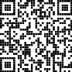

Scan the QR code to verify authenticity.

Authorized Signature

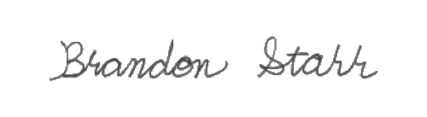

Brandon Starr, Lab Manager Thu, 24 Aug 2023 16:01:44 -0700

## PharmLabs San Diego | 3421 Hancock St, Second Floor, San Diego, CA 92110 | 619.356.0898 | ISO/IEC 17025:2017 Accredited L17-427-1

*This report shall not be reproduced except in full, without the written approval of the lab. This report is for informational purposes only and should not be used to diagnose, treat or prevent any disease. Results are only for samples and batches indicated. Results are reported on an "as received" basis, unless indicated otherwise. When a Pass/Fail status is reported, that status is intended to be in accordance with federal, state and local laws which are required for the customer to be in compliance. The measurement of uncertainty is not included in the Pass/Fail evaluation unless explicitly required by federal, state or local laws and has been reported on the certificate of analysis. Measurement of uncertainty is available upon request.